Little SPARK: Simple Play Adaptations to Reference for Kids

Choice Board
Description: | Image:
The self-standing Choice Board Trifold is made of VELTEX® Brand loop-fabric. It can be stored flat and/or folds into a triangular position with hook and loop closure. The versatility of the board surfaces suggests the Choice Board Trifold can also be used for picture schedules or a simple communication board display. | 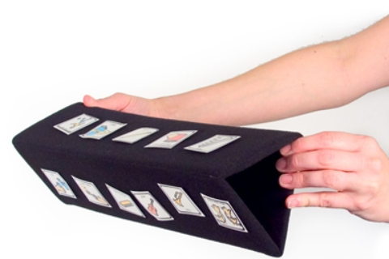

Who Might Benefit?
Those who have difficulty understanding verbal instructions, competing multi-step activities, or need additional support to indicate needs or choices.
Why Use?
Provides an opportunity to make choices, follow directions with fewer verbal prompts, and visuals to support following schedules, routines, and adult directions.
Instructions for Use: | Adaptation Ideas:
Environmental Considerations  - Use in any environment and on the go.  Positioning & Alternate Positioning  - Use in any position, flat or folded into a triangle, or position vertically to view visual symbols as a list.  Basic Play/Use  - Display choices, directions (e.g. classroom management), communication supports (e.g. requesting), or sequences (e.g. self-care).  Extended Play/Use  - Use during story time to display symbols of characters or sequence of events. | Build It Up  - Use physical objects in place of picture cards.  Stabilize It  - Velcro to most surfaces.  Add Sensory Cues  - Add contrasting backgrounds or high contrast visuals.  - Add sensory cues to visuals.  Alternative Uses  - Use as a story-telling board when folded flat.

Words to Encourage Play/Use
Which one?  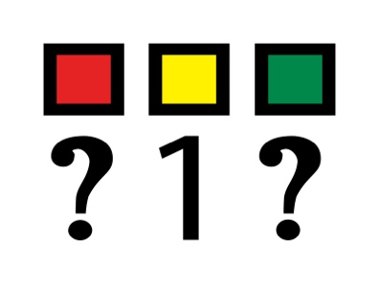 | Done   | Wait  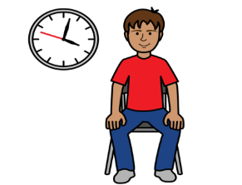
What do you want next?  | Show me | Help  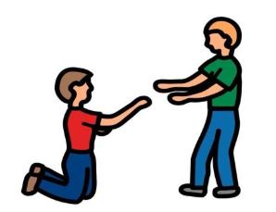
What’s next?  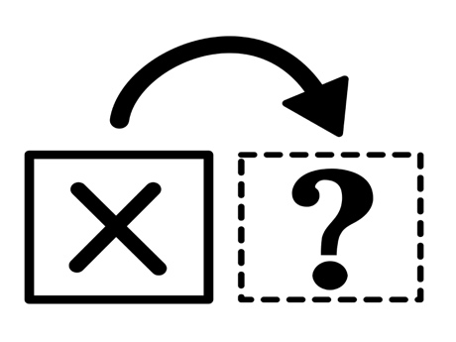 | Then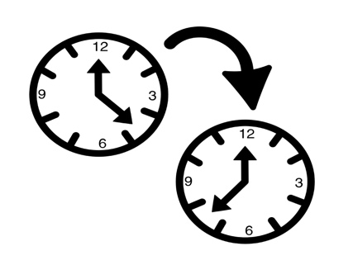 | Next  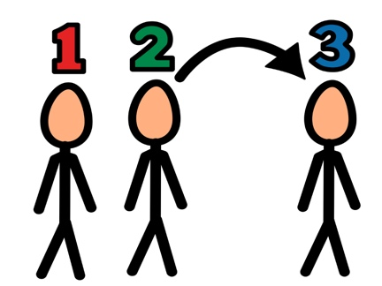
*”Adaptations” adapted from: Haugen’s Modes for Adapting Toys based on materials from the "Let's Play" Project at the University of Buffalo
PCS is a trademark of Tobii Dynavox, LLC. All rights reserved. Used with permission.

